

StayBeautiful

User Manual

Version 1.0

December 2016

TABLE OF CONTENTS

1. INTRODUCTION 3

1.1 BACKGROUND 3

1. 2 ABOUT STAYBEAUTIFUL 3

2. BASICS 3

2.1 RUNNING WEBSITE ON LOCAL SYSTEM 3

2.2 RUNNING WEBSITE ON ELLA 5

3. ROLES 6

3.1 ADMIN 6

3.2 SELLER 8

3.3 BUYER 9

4.OTHER FUNCTIONALITIES 10

5.CONCLUSION 14

1. INTRODUCTION
   1. Background

This user manual documentation is to help the user to maintain, update and use the ecommerce website. The detailed screenshots of how to use the website are given.

* 1. About staybeautiful

StayBeautiful is an ecommerce website which focuses on selling beauty products and heath supplements. Many professional brands such as L’Oréal Professional, Estee Lauder etc. use their own product for product advertisement and promotional purpose but do not provide feature to purchase products online. StayBeautiful is a one stop destination to purchase famous and professional cosmetics and over the counter health supplements. We offer comparable prices and free shipping. We also offer sample products at the time of checkout.

1. BASICS
   1. Running website on local system

Install Xampp version 7 which is a free and open source cross-platform webserver solution developed by Apache Friends.

Link: <https://www.apachefriends.org/download.html>

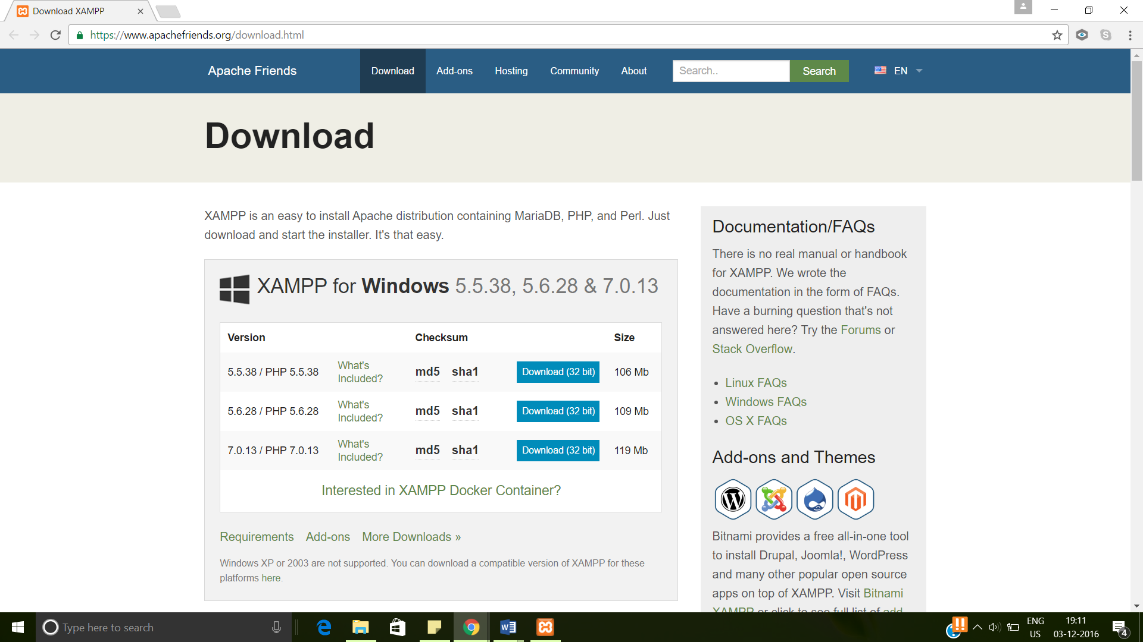

A new folder xampp should be created in the C folder. Go to xampp folder in C folder. Click on Xampp- control. A control panel window will pop up.

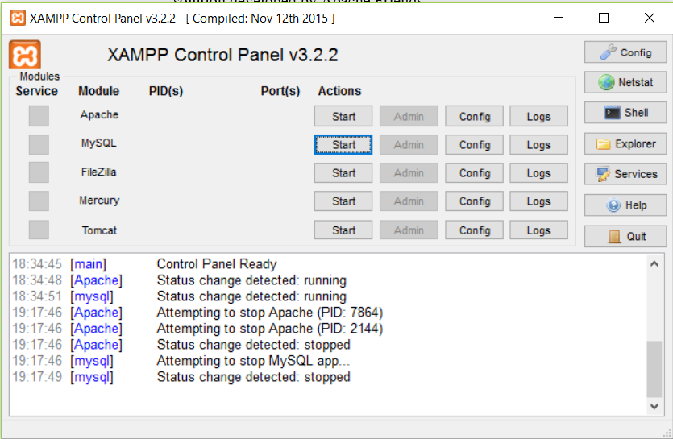

Start the Apache and MySQL modules from the XAMPP Control Panel.

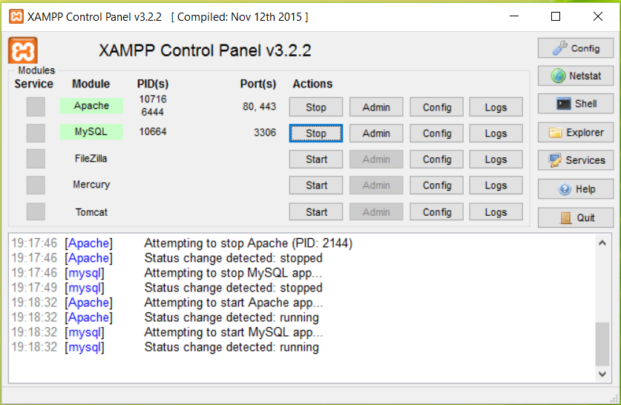

Navigate to localhost/phpmyadmin

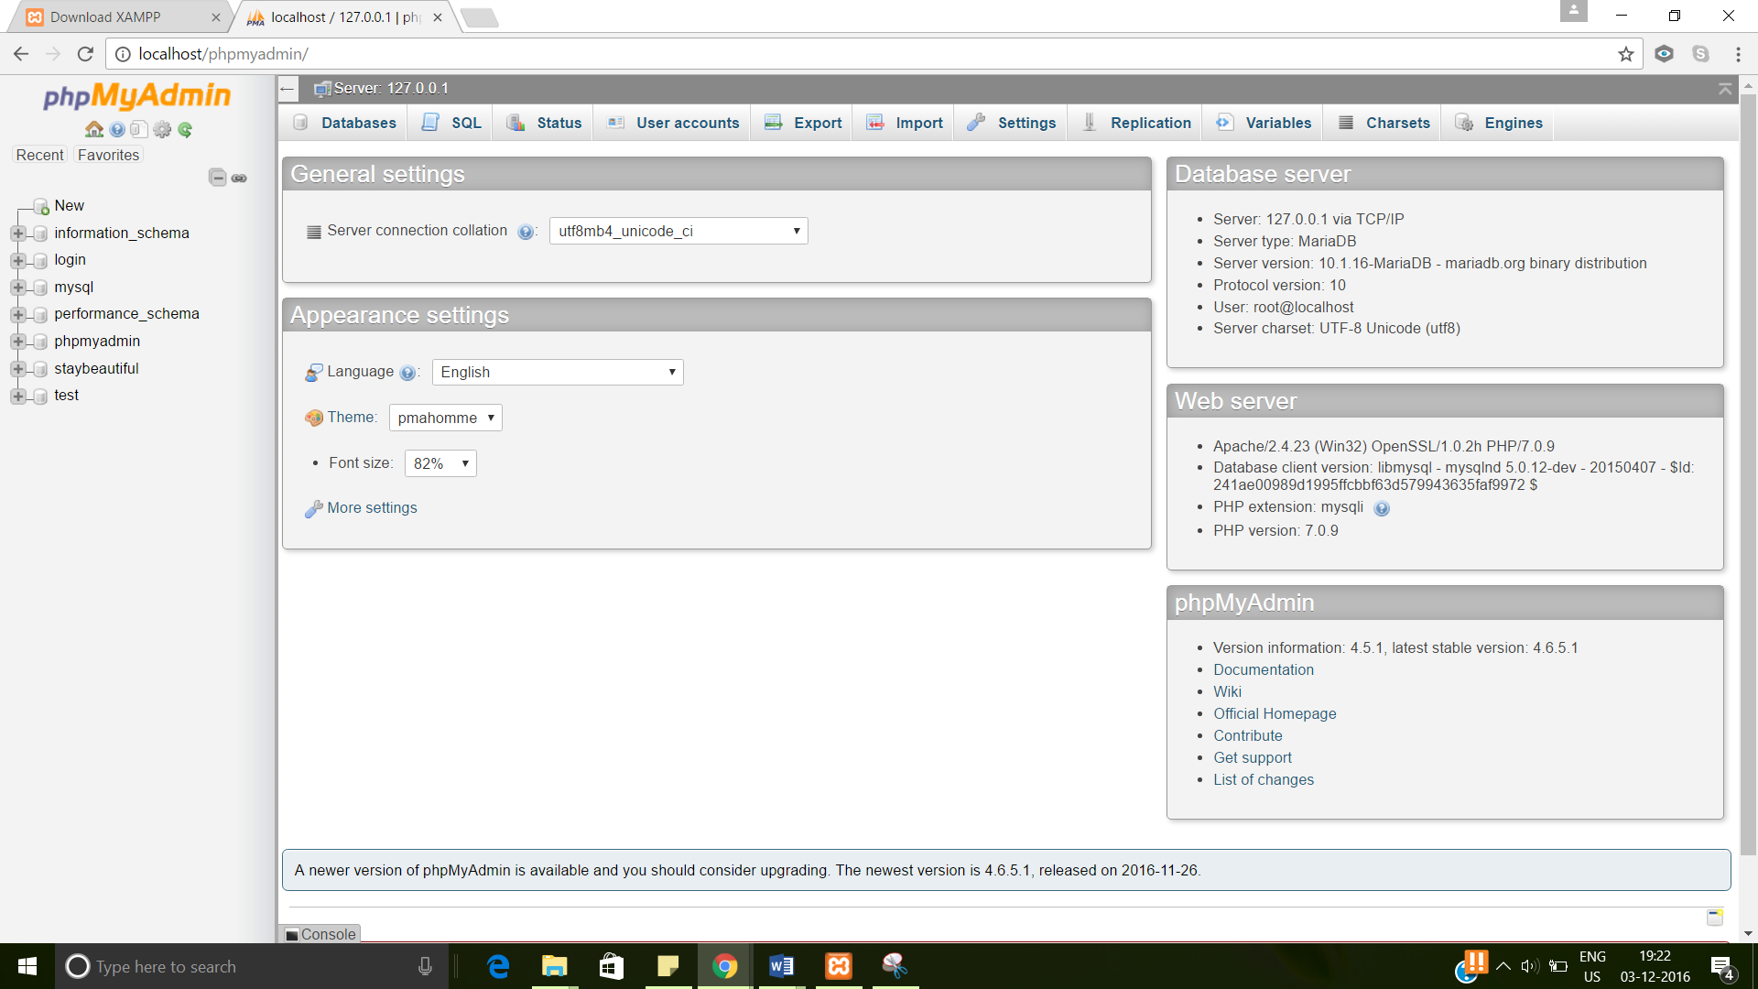

Create 2 databases- staybeautiful and login

Import inventory, menu, orderconfirmation, rating, review and sub menu tables in the staybeautiful database.

Import Admin, members, members1 table in the login database.

The tables are a part of deliverables.

Copy the StayBeautiful folder which has the source code in the C:\xampp\htdocs location.

The website can be run on local host now.

Go to web browser and type the address as localhost/staybeautiful

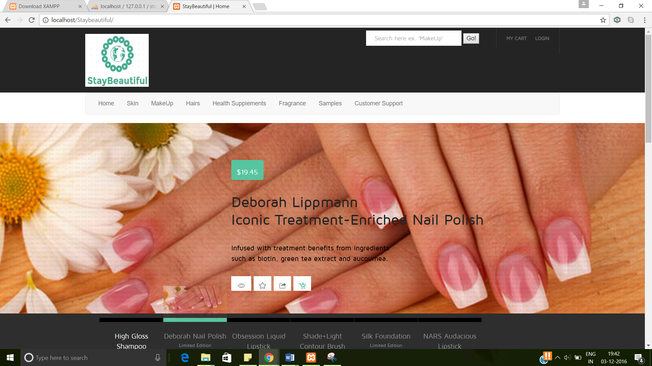

* 1. Running website on ELLA:

We have hosted our website on the SOIC server “Ella”.

To run the website hosted on ella ( SOIC Server)

1. Go to any system’s web browser and type the address as <http://ella.ils.indiana.edu/~vsainaat/xampp/htdocs/SE/StayBeautiful/>

2. The features of the website can be accessed through directly from any computer and browser using the ella link.

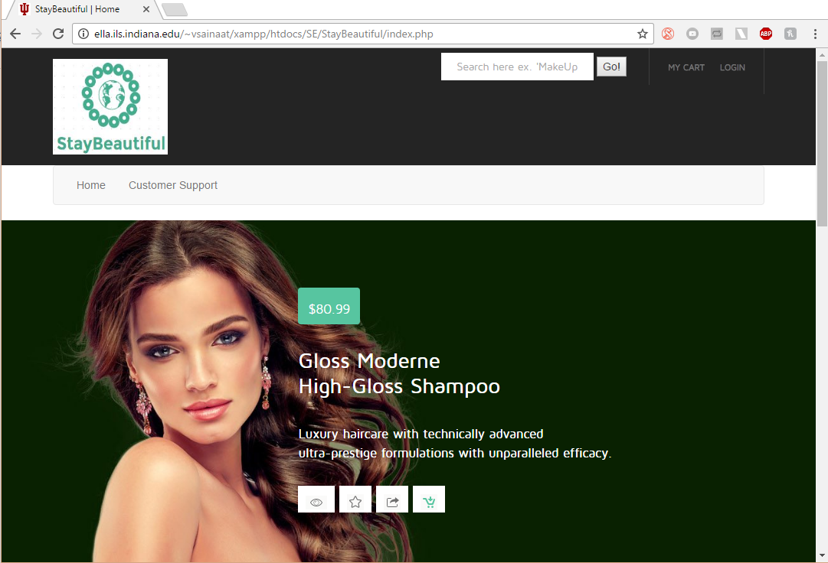

To host the website on ella:

1. Create an account on ella.
2. Create an account for MySQL database in SOIC server.
3. Import all the tables to the server MySQL database .
4. Change the hostname, username , password and database names accordingly on all php files for a succesfull MySQL database connection.
5. Connect to Ella server using IU user id and password and paste the XAMPP folder inside C:/
6. Now the website can be accessed through any system since its hosted successfully.
7. Roles
   1. ADMIN

The Admin can login to the website using the Login type

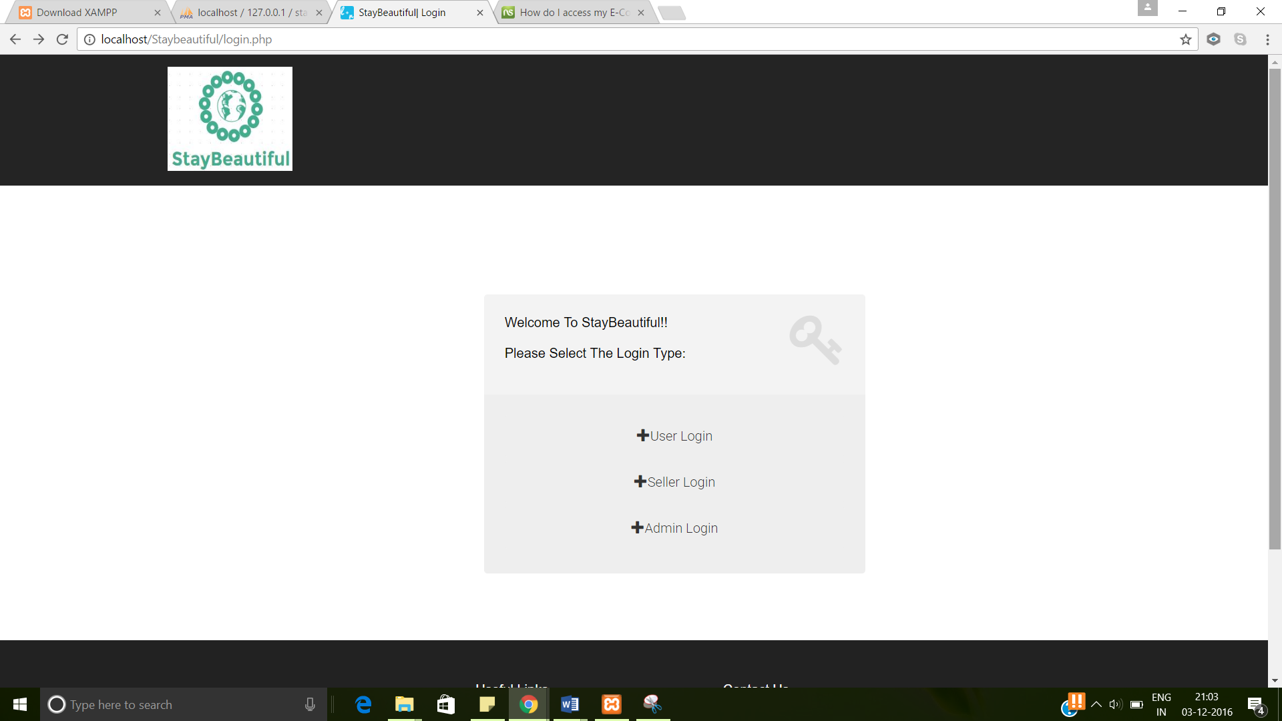

The Admin is displayed a list of all the products in the inventory. The admin can add new discount offers for any products or can delete the discount offers associated with other products. The admin can also add new promocode to any of the products or can delete existing promocode offers.

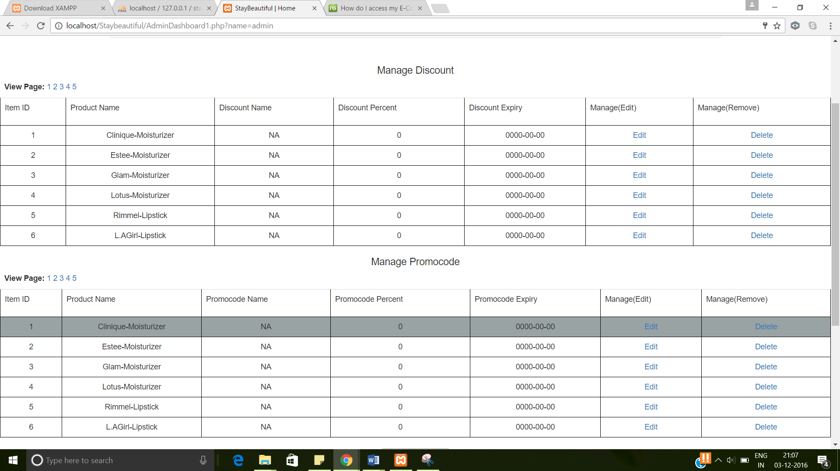

The Admin can also generate a Yearly report. The report displays the products sold, Seller name, Date and price.

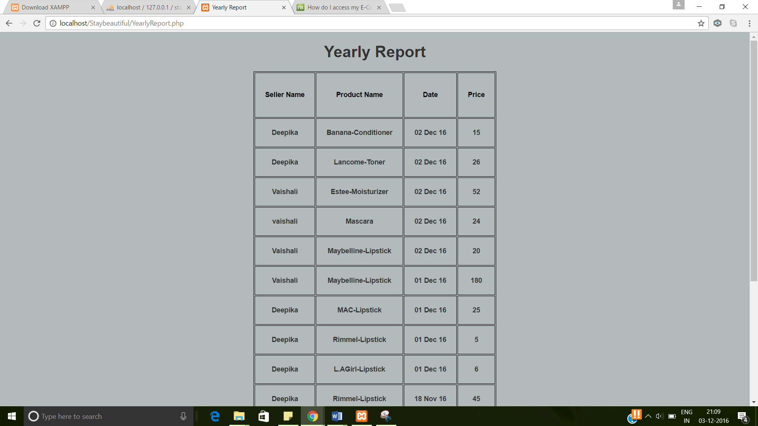

The Seller statistics displays the items a particular seller has sold and also the total quantity left in the inventory.

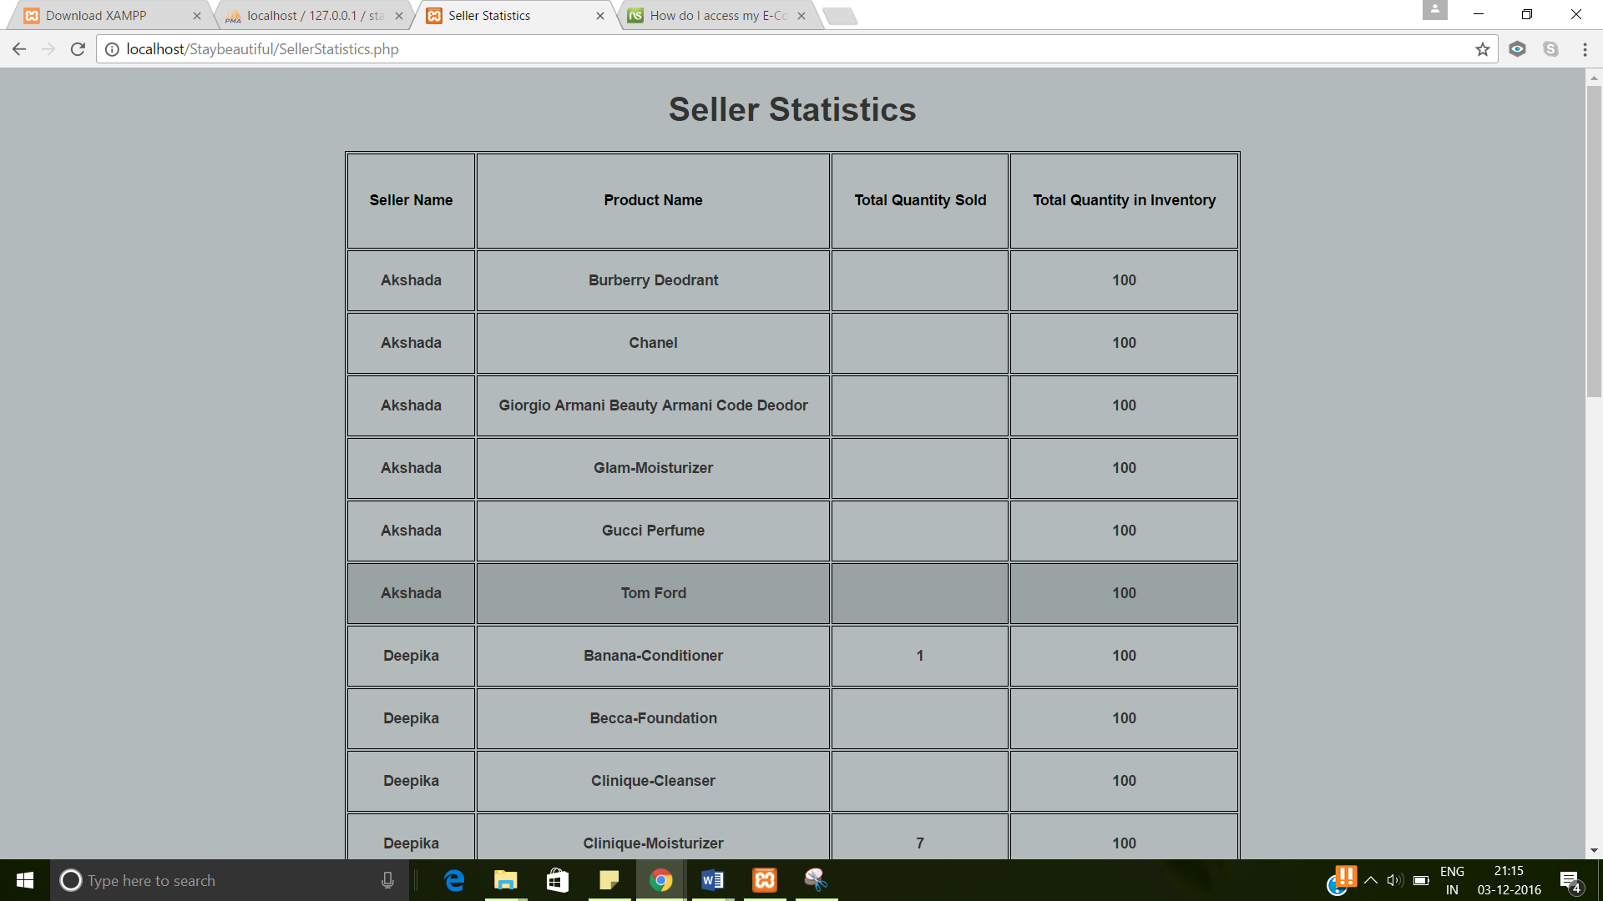

* 1. SELLER

The Seller can login in the website by using seller login.

The Seller can generate the revenue report where the items that the seller has sold and the total price is displayed.

The items sold report displays a list of items sold by the seller and the quantity of the products.

The Seller can add a product in the inventory by clicking on the Update Inventory button.

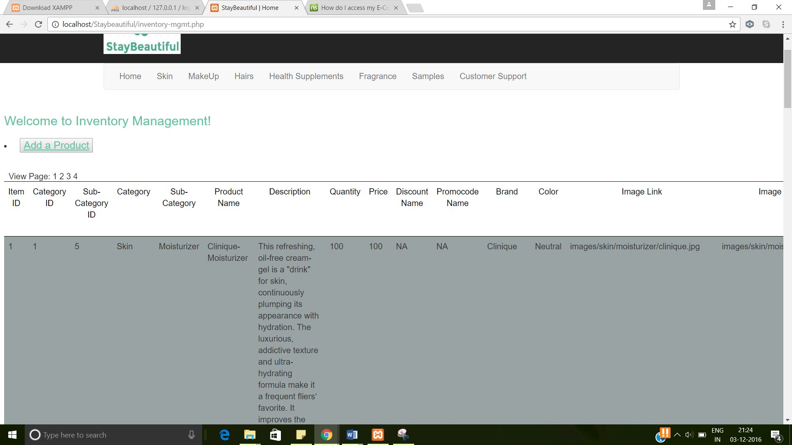

The Seller can then add the required details of the product to add it in the inventory.

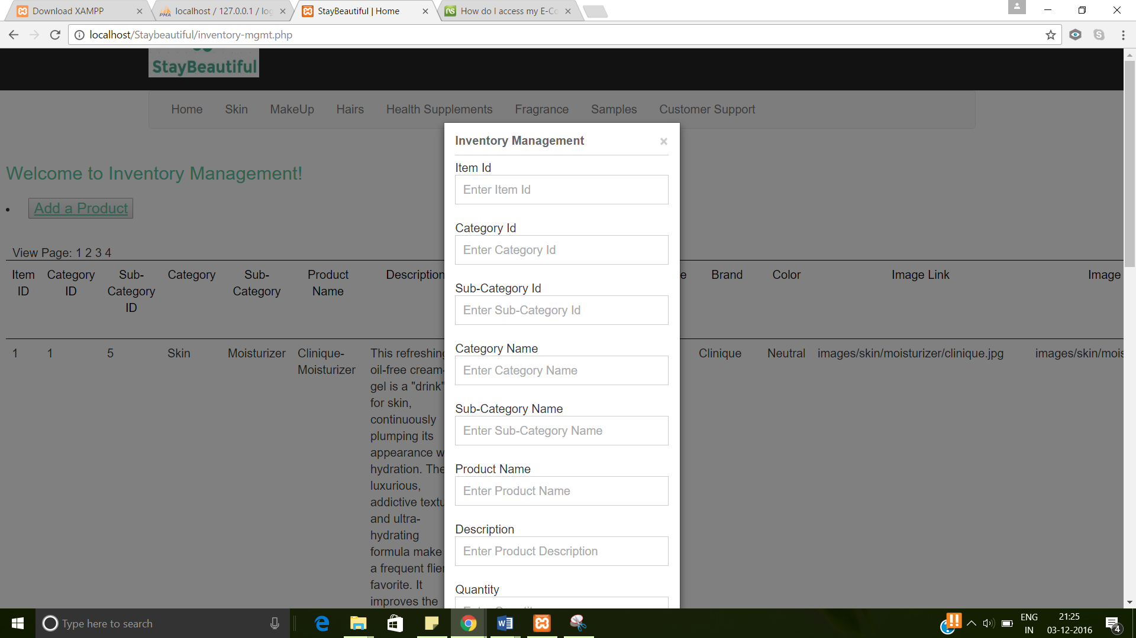

The seller can also update his personal information.

* 1. BUYER

The buyer can login in the website by entering the buyer credentials.

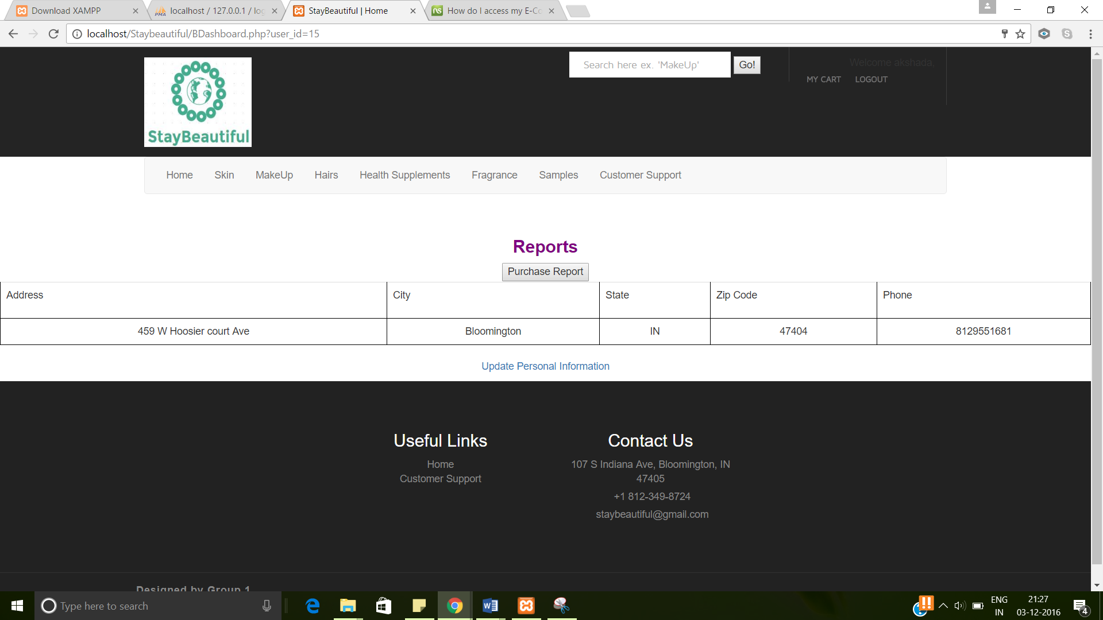

The buyer can update his personal information by clicking on the Update personal information link.

The purchase report displays the products purchased by the user, the price, date and the quantity.

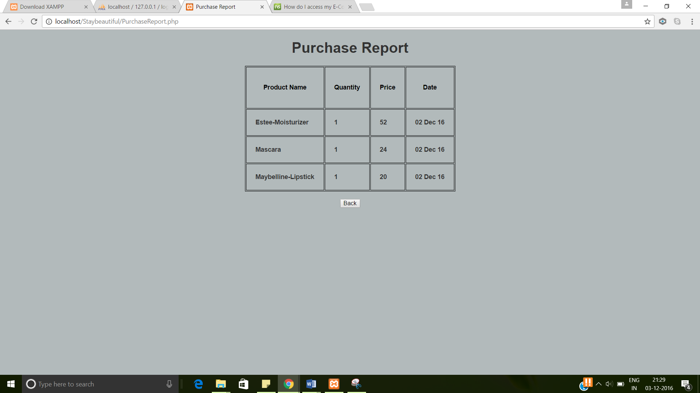

1. other functionalities

The user can browse through all the products displayed on the dynamic menu.

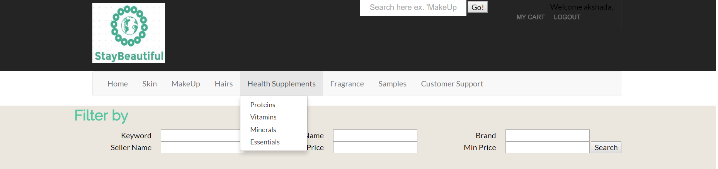

The user can also navigate or search products by using the Filter by option.

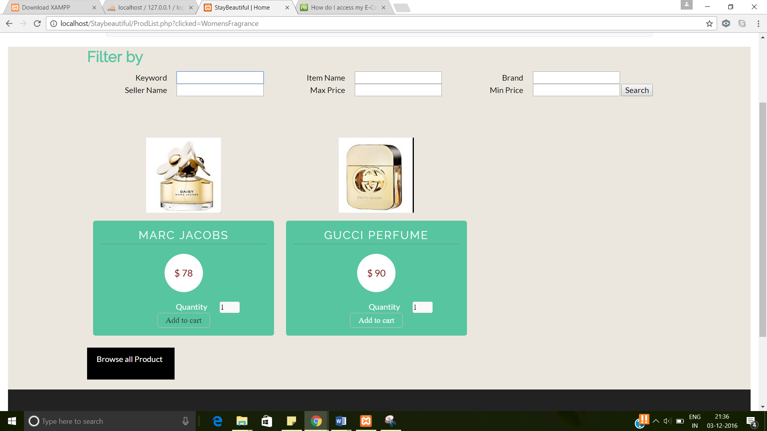

The user can view the description of every product by navigating to product description page by clicking on the product results obtained through search. The user can also provide the reviews and star rating to the products and can see the reviews and ratings given by other users.

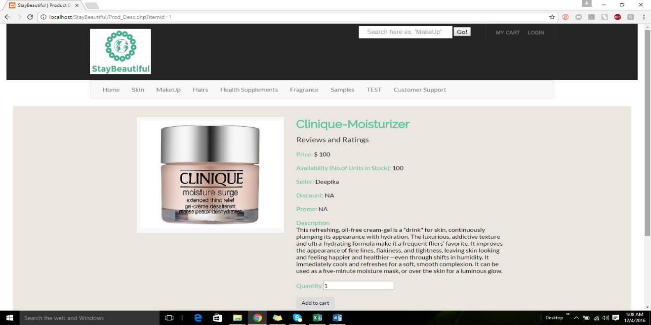

The user can add a product to the cart by clicking on the ‘Add to cart’ button.

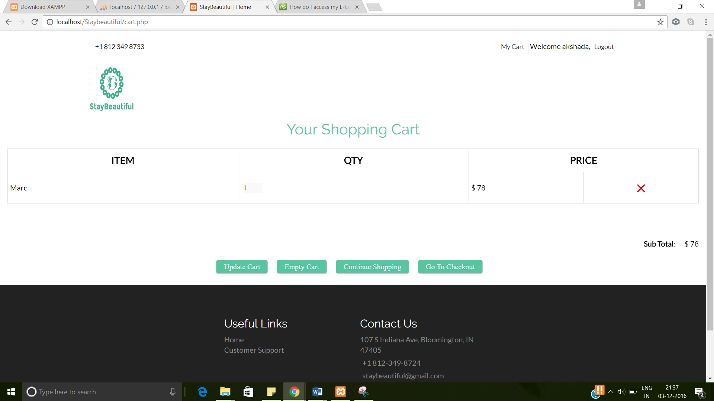The user can then click on the checkout button.

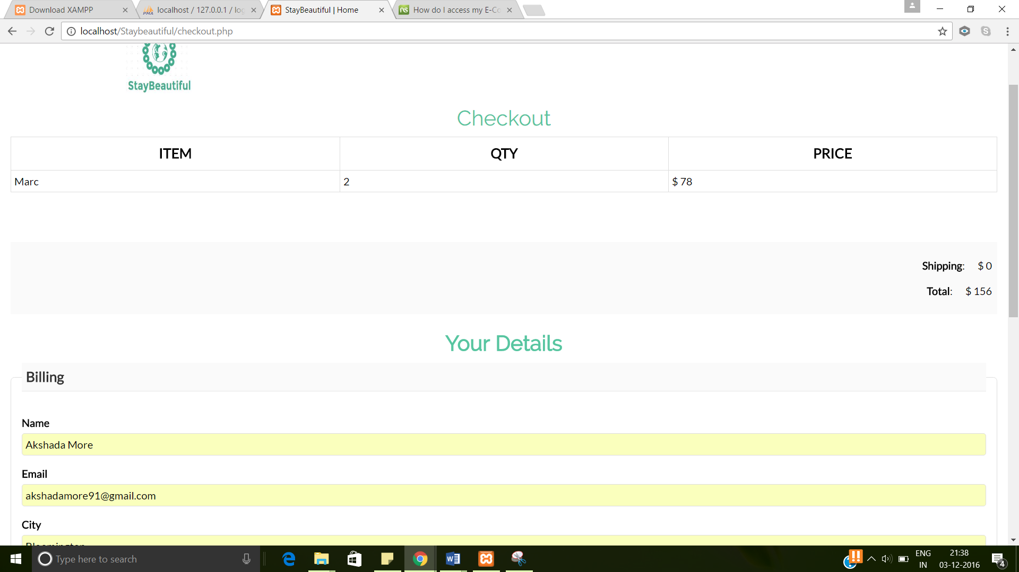The user should enter all the required information and then procced to checkout.

The user is then navigated to the Payment details screen.

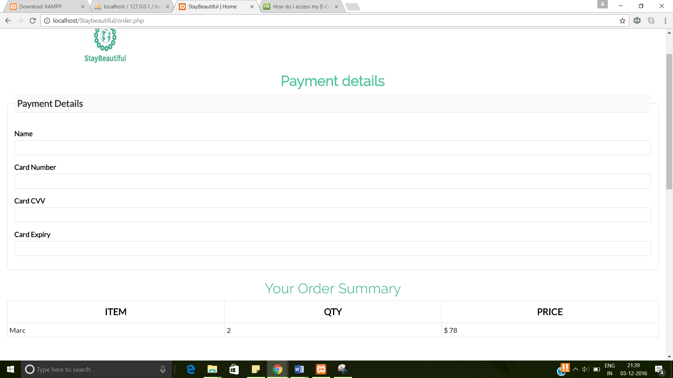On entering the required information, the user can place the order.

User can also contact the customer support by filling the customer support form available in the Customer Support menu option. The user will receive an automated email after submitting the customer support form.

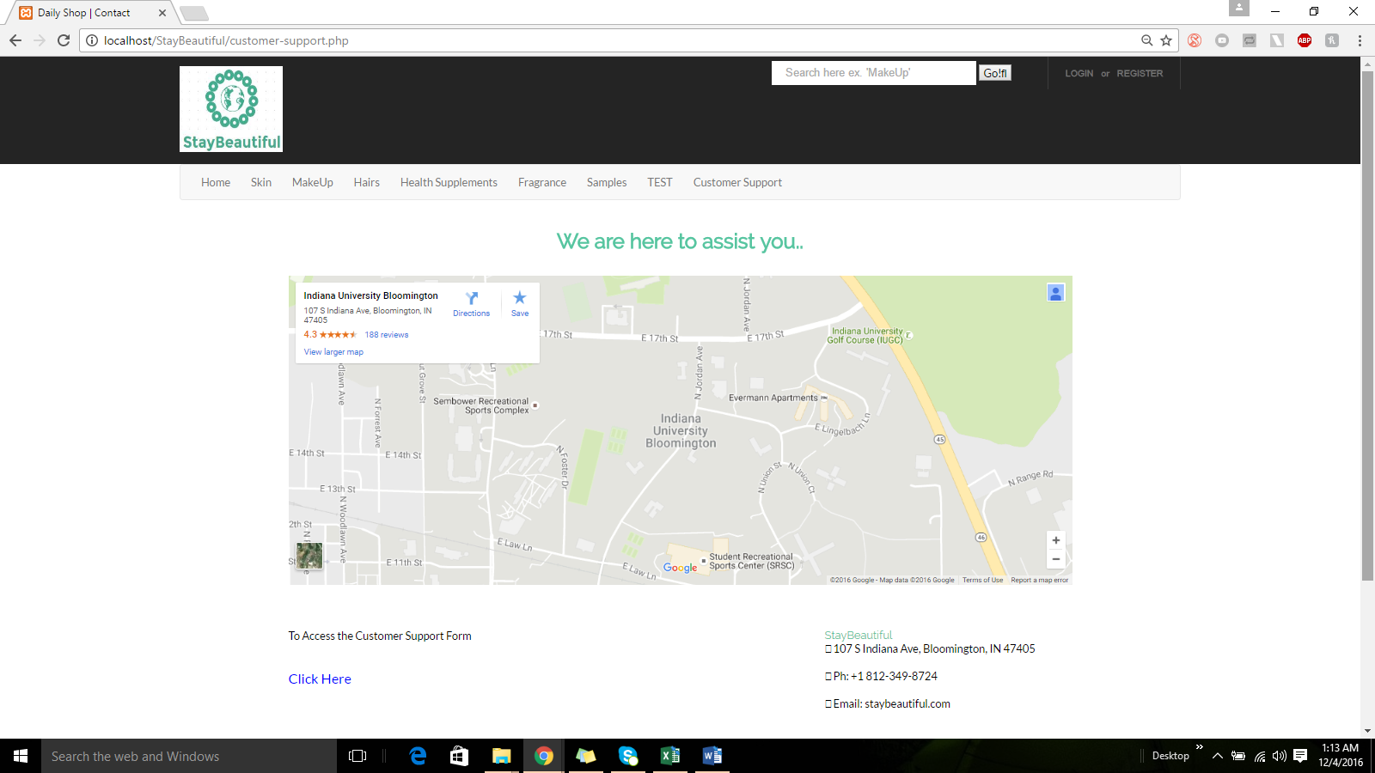

1. conclusion

This manual was created with the most common questions in mind, and kept short. If your questions are not answered here you can contact us at:

